**Code Challenge: 4**

Time: 45 Min

1.

Write a JavaScript program to calculate multiplication and division of two numbers (input from user).

Sample Form:

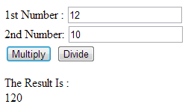

--------------------------------------------------------------------------------------------------------------------------------

2.

Write a JavaScript for loop that will iterate from 0 to 15. For each iteration, it will check if the current number is odd or even and display a message to the screen.

**Sample Output:**

" 0 is even "  
" 1 is odd "  
" 2 is even "